**SEQUENCE DIAGRAMS**

**Sequence diagram** is the most common kind of [**interaction diagram**](http://www.uml-diagrams.org/uml-25-diagrams.html#interaction-diagram), which focuses on the [**message**](http://www.uml-diagrams.org/sequence-diagrams.html#message) interchange between a number of [**lifelines**](http://www.uml-diagrams.org/sequence-diagrams.html#lifeline).

Sequence diagram describes an interaction by focusing on the sequence of messages that are exchanged, along with their corresponding occurrence specifications on the lifelines.

***Lifeline*** is a [**named element**](http://www.uml-diagrams.org/uml-core.html#named-element) which represents an **individual participant** in the interaction. While [**parts**](http://www.uml-diagrams.org/composite-structure-diagrams.html#part) and structural features may have multiplicity greater than 1, lifelines represent **only one** interacting entity.

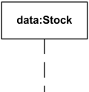

***Lifeline****"data" of class Stock*

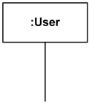

*Anonymous lifeline of class User*

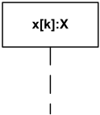

***Lifeline****"x" of class X is selected with****selector****[k]*

***Message*** is a [**named element**](http://www.uml-diagrams.org/uml-core.html#named-element) that defines one specific kind of communication between [**lifelines**](http://www.uml-diagrams.org/sequence-diagrams.html#lifeline) of an interaction. The message specifies not only the kind of communication, but also the sender and the receiver. Sender and receiver are normally two **occurrence specifications** (points at the ends of messages).

Syntax for the message is:

***message*** ::= [ ***attribute*** '=' ] ***signal-or-operation-name*** [ ***arguments*** ] [ ':' ***return-value*** ]  | '*'   
***arguments*** ::= '(' [***argument***  [ ',' ***argument***]* ')'   
***argument*** ::= [ ***parameter-name*** '='] ***argument-value*** | ***attribute*** '=' ***out-parameter-name*** [ ':' ***argument-value*** ]  | ' -'

Arguments of a message could only be:

* attributes of the sending lifeline,
* constants,
* symbolic values (which are wildcard values representing any legal value),
* explicit parameters of the enclosing interaction,
* attributes of the class owning the interaction.

***EXAMPLE OF A SEQUENCE DIAGRAM:***

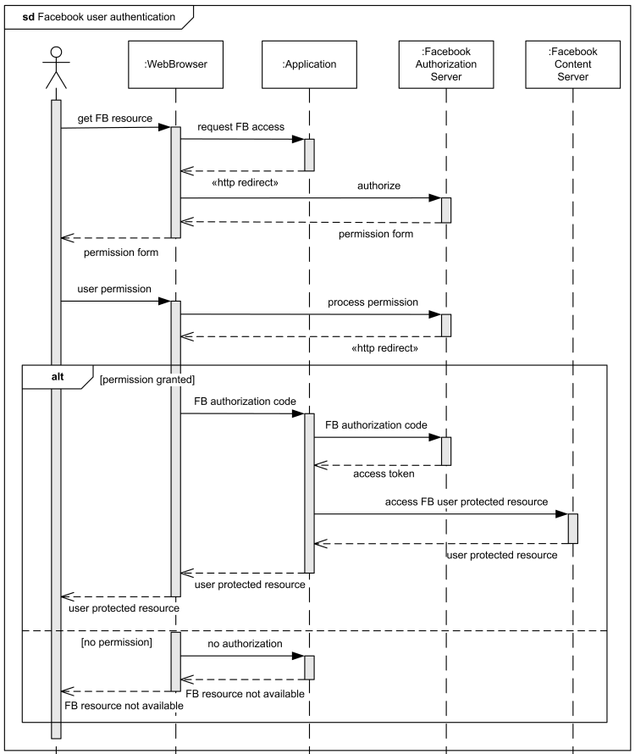

*Sequence diagram example - Facebook User Authentication in a Web Application.*